*Additional Weed Killers:* With numerous kid-, pet- and earth-friendly ways to rid your

garden of pesky weeds, here are nine stand-outs to put to the test.

*By*[*JENNIFER NOONAN*](https://www.bobvila.com/authors/Jennifer-Noonan)

**1. By Hand**

You can rid yourself of weeds the old fashioned way—pulling them by hand—if you're vigilant. Wear a dedicated pair of [gardening gloves](https://www.amazon.com/Bamboo-Gardening-Gloves-Protective-Working/dp/B00W5TGD3W/?&_encoding=UTF8&tag=ss-caption-20&linkCode=ur2&linkId=6c0148f17f81bf1fe258039cba050402&camp=1789&creative=9325) for the task to avoid inadvertently transferring seeds elsewhere. Good [gardening tools](http://www.bobvila.com/garden-basics/44279-9-essential-tools-for-every-gardener/slideshows) like a claw or sharp trowel can help you loosen the weed roots from the soil ﬁrst. Pulling a weed completely out by the root is the only way to ensure it will not return.

[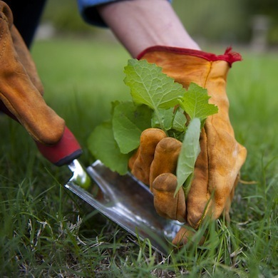](https://s3-production.bobvila.com/slides/5042/original/slide1.jpg?1475706659)Photo: *shelmerdine.com*

**2. Mulch**

Cover your planting areas with [mulch](http://www.bobvila.com/articles/how-to-mulch-your-flower-beds/) and you’ll keep weed seeds from coming into contact with the soil in the ﬁrst place. Mulch will also keep sunlight from reaching seeds that are already underground, so they won’t get a chance to sprout. [Mulch](https://www.amazon.com/Planters-Pride-RZP3056-PlantBest-8-8lbs/dp/B003UHVVX0?&_encoding=UTF8&tag=ss-caption-20&linkCode=ur2&linkId=b96460cc54ba1fea2806367a5ad6e762&camp=1789&creative=9325) offers the added beneﬁts of retaining moisture and breaking down to enrich your soil. And it looks really pretty, too.

[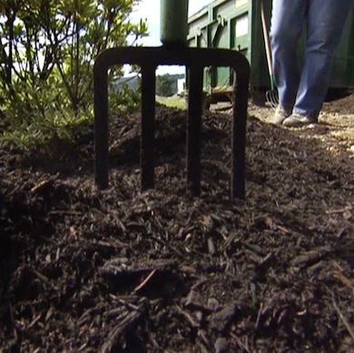](https://s3-production.bobvila.com/slides/5044/original/slide3.jpg?1475706663)  [Photo: *hgtv.com*](http://hgtv.com/)

**3. Vinegar**

Apply vinegar with a spray bottle, pump sprayer, or brush. Like other natural herbicides, vinegar cannot differentiate between weeds and other plants. Do this early in the morning, when there’s little wind, to avoid contaminating nearby plants. Vinegar’s killing properties are activated by the sun, so try this on a cloudless day, which also ensures that rain won’t wash it off before it works its magic.

[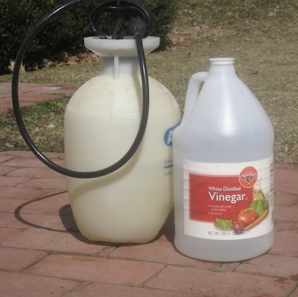](https://s3-production.bobvila.com/slides/5045/original/slide4.jpg?1475706664)  [Photo: *agardenforthehouse.com*](http://agardenforthehouse.com/)

**4. Newspaper**

Smother weeds and prevent new ones from growing by covering them with old newspapers. A thick layer of newspaper will keep sunlight from reaching weed seeds, so they can’t sprout. Wet the soil ﬁrst, and then lay your newspaper down, wetting it thoroughly again before covering with mulch. This is a great way to recycle, and as a bonus, you’ll encourage earth worms to come and stay.

[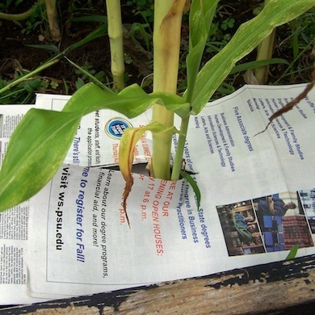](https://s3-production.bobvila.com/slides/5046/original/slide5.jpg?1475706667) Photo: [gardeningjones.com](http://gardeningjones.com/)

**5. Boiling Water**

Scald those pesky weeds with boiling water. Just grab your kettle off the stove and bring it to the garden. Pour a stream of water carefully on the crown of each unwanted plant. Tough perennial weeds with long tap roots may take two or three applications, but will eventually stop coming back. Use your hot pads, of course, and deﬁnitely take the precaution of wearing long pants and close-toed shoes.

[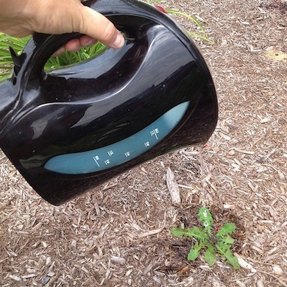](https://s3-production.bobvila.com/slides/5047/original/slide6.jpg?1475706669) Photo: [flickr.com](http://flickr.com/)

**6. Salt**

Regular old table salt is very effective at killing weeds. Put just a pinch down at the base of each plant. It will kill the weedy offender and get diluted within a couple of rainfalls. Salt will render the soil uninhabitable for several months, so make sure you apply just a small amount and only where needed. Avoid getting it on your grass or other plants.

[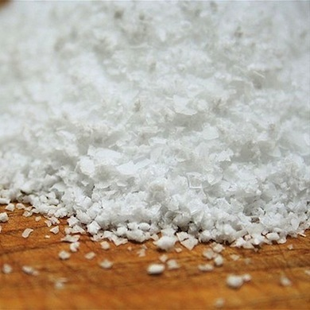](https://s3-production.bobvila.com/slides/5048/original/slide7.jpg?1475706671) Photo: [washingtonian.com](http://washingtonian.com/)

**8. Herbicidal Soap**

Make your own DIY herbicidal soap by mixing equal parts vinegar, salt and dish soap. Put the mixture in a spray bottle and apply it to your offending weeds. But be judicious. This concoction will kill whatever plants it touches, so be careful not to get it on your prized perennials.

[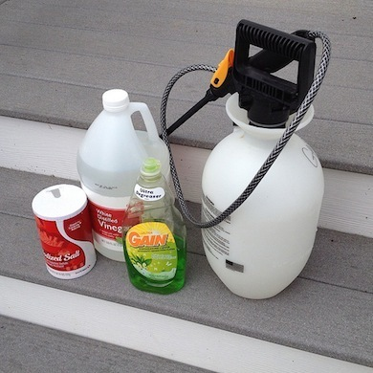](https://s3-production.bobvila.com/slides/5049/original/slide8.jpg?1475706672)

**9. Weed Torch**

A weed torch works by heating the water within the cells of plants. When the water turns to steam, the cells explode and the plant will die. You don’t need to char the weeds, just wilt them. This takes some practice, but is very effective. Don’t ever use it on poison ivy or other poisonous plants because it can release poison oils into the air and ultimately into your eyes or lungs.

[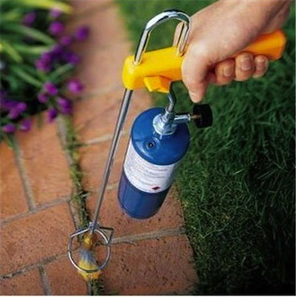](https://s3-production.bobvila.com/slides/5050/original/slide9.jpg?1475706674) Photo: [uberreview.com](http://uberreview.com/)